UCSC Study #: HS-FY2023-193   
UCSB Study #: 24-0294

Study Title: Equity in California Ocean Access & Management

Timothy Frawley and Jennifer Selgrath, who are affiliated with UC Santa Cruz and the California Marine Sanctuary Foundation, are conducting a research study to learn more about ocean access and benefits.

If you agree to be in this study, you will complete an online survey. The survey will ask you a series of questions about how you use and/or value the ocean, and how these uses and values are (or could be) impacted by environmental change, socioeconomic change, and/or shifting management and regulations.

Your participation will take about 15-25 minutes.

You will be entered in a drawing for a prize to compensate you for your participation in the study and given the opportunity to win a charter fishing, island day trip, or whale watching trip (4 persons maximum) departing from Fisherman’s Wharf (San Francisco), Moss Landing Harbor (Monterey), Santa Barbara Harbor, or Ventura Harbor. Prize winners will be selected randomly and contacted via email no later than December 15, 2024.

Research records will be kept confidential to the extent allowed by law. Though you are required to provide an email address to enter the lottery drawing, this information will not be shared beyond the research team and will not be linked to the data associated with the survey responses that you provide.

Participation in research is entirely voluntary and you can withdraw at any time by simply closing/not submitting the survey. You are free to skip any questions you do not want to answer. Choosing not to participate or withdrawing will in no way result in loss of benefits or services to which you are otherwise entitled.

If you want additional information or have questions or research-related problems, you may reach Timothy Frawley at tfrawley@ucsc.edu

By completing and submitting the study survey you are indicating that you are at least 18 years old, have read this consent form, agree to participate in this research study, and have not taken the survey before. Once the survey is submitted, answers are anonymous and cannot be withdrawn.

UCSC Study #: HS-FY2023-193   
 UCSB Study #: 24-0294

# **Equity in California Ocean Access & Management**

# ***We’re interested in your experiences with any beach, bay, pier, jetty, coastal area, island, or other place near the ocean or bays in California, which will be referred to in the survey as “ocean & coastal areas.”***

# ***First, we are interested in how much time you spend at the ocean and coast IN CALIFORNIA.***

1. Please complete the following sentence, “In comparison with the amount of time I currently spend at ocean and coastal areas in California, I would prefer to spend…”

* A lot more time
* More time
* The same amount of time
* Less time
* A lot less time

1. How often do you spend time in ocean & coastal areas in California?

* Several times per week
* Several times per month
* Once every couple months
* Once a year
* Less than once a year (i.e., rarely or never) **🡪 SKIP to Q10**

1. What is the ocean or coastal area (i.e., beach, park, pier, surf break etc.) in California where you **spend the most time (**e.g., Huntington Beach, Golden Gate National Park, Ventura Pier, Steamer’s Lane, etc.) ?   
   Location: _______________________________________________________

***We will now ask you about activities that you participate in when you spend time at the ocean and coastal areas IN CALIFORNIA.***

1. When you spend time in ocean & coastal areas in California, what activities are **important** to you and that you participate in at least once a year? (check all that apply)

**Activity**

* Beach games or sports (e.g., frisbee, volleyball, etc)
* Bicycling, roller skating, skateboarding, etc
* Cultural or religious practices or ceremonies
* Driving or sitting in your car to enjoy the views/sunsets
* Festivals with music and food (e.g., earth day)
* Fishing or collecting food
* Group or family gatherings or activities (e.g., family outing, bbq, picnic, party, etc.)
* Meditation, reading, and/or relaxing
* Observing or photographing nature or wildlife, outdoor education
* Sailing/Boating (engine powered)
* Snorkeling/Scuba Diving
* Surfing
* Stand up paddleboarding/kite or sailboarding/kayaking
* Swimming or bodysurfing
* Walking or running
* Volunteering (e.g., beach clean-ups)
* Paid work
* Other, please specify: _____________________________________
* None of the above

***We’d now like to ask about the time that you spend at the coast and oceans.***

1. From the list in Q4, **pick one activity that is important to you**:

* Beach games or sports (e.g., frisbee, volleyball, yoga, dancing)
* Bicycling, roller skating, skateboarding, etc
* Cultural or religious practices or ceremonies
* Driving or sitting in your car to enjoy the views/sunsets
* Festivals with music and food
* Fishing or collecting food
* Group or family gatherings or activities (e.g., family outing, bbq, picnic, party, etc.)
* Meditation, reading, and/or relaxing
* Observing or photographing nature or wildlife, outdoor education
* Sailing/Boating (engine powered)
* Snorkeling/Scuba Diving
* Surfing
* Stand up paddleboarding/kte or sailboarding/kayaking
* Swimming or bodysurfing
* Walking or running
* Volunteering (e.g., beach clean-ups)
* Paid work
* Other, please specify: _____________________________________
* None of the above

1. What is your usual mode of transportation to [**ACTIVITY identified in Q5**]? (check one)

* Bicycle
* Getting a ride from friends or family
* Personal vehicle
* Public transportation (i.e., bus/train/metro/subway)
* Taxi services (including rideshare options, such as Uber, Lyft)
* Walking
* Other, please specify: __________________________

1. How many minutes are you willing to travel each way to [**ACTIVITY identified in Q5]**

* Less than 15 minutes
* Less than 30 minutes
* Less than 1 hour
* Less than 2 hours
* More than 2 hours

1. Who first taught you about or introduced you to **[ACTIVITY identified in Q5]**?(check all that apply)

* I taught myself or I started by myself
* Family member taught me (parent, sibling, cousin, etc)
* Friends or colleagues
* School, class, group, religious community, club, etc
* Cultural practitioner (Indigenous or traditional knowledge holder)
* Other, please specify: _______________________________

1. Who do you do [**ACTIVITY identified in Q5**] with?   
   (check all that apply)

* Alone
* With family
* With friends or colleagues
* With school, class, group, religious community, club, etc.
* With a cultural practitioner (Indigenous or traditional knowledge holder)
* Other, please specify: ________________________

5a. If you checked ‘fishing or collecting food’ in **Q5** as an important activity [**otherwise SKIP this and the two questions below**], which of these fishing activities do you **participate in regularly** (**once every two or three months**)? (check all that apply).

* Collecting/gathering marine life like mussels, snails, or algae from shallow/intertidal areas
* Fishing from piers and jetties using fishing rod, trap, or other gear
* Fishing from beaches and banks using fishing rod, trap, or other gear
* Fishing from a boat using fishing rod, trap, or other gear
* I do not fish or gather marine life

5b.1 Please list up to **three marine species** (i.e., mussels, halibut, kelp, etc.) that you most commonly target when fishing or harvesting:

|  |  |
| --- | --- |
|  | **Targeted Species** |
| 1. |  |
| 2. |  |
| 3. |  |

5c. What usually happens to marine species you listed above? (check all that apply)

* Given away
* Caught and released (i.e., throw back)
* Sold
* Eaten
* Bait
* Cultural/ artistic/ traditional use

5b.2 If you checked ‘cultural or religious practice or ceremonies’ in **Q5** as an important activity **[otherwise SKIP]** , please list up to **three marine species** (i.e., mussels, pelicans, halibut, kelp, etc.) that you most frequently incorporate into cultural or religious practices or ceremonies:

|  |  |
| --- | --- |
|  | **Species** |
| 1. |  |
| 2. |  |
| 3. |  |

5b.3 If you checked ‘observing or photographing nature or wildlife, outdoor education’ in **Q5** as an important activity **[otherwise SKIP]**, please list up to **three marine species** (i.e., mussels, pelicans, halibut, kelp, etc.) that you most enjoy observing, photographing, or learning, about::

|  |  |
| --- | --- |
|  | **Species** |
| 1. |  |
| 2. |  |
| 3. |  |

5b.4 If you checked ‘snorkeling/scuba diving’ in **Q5** as an important activity **[otherwise SKIP]**, please list up to **three marine species** (i.e., mussels, pelicans, halibut, kelp, etc.) that you most enjoy observing or interacting with when snorkeling and/or scuba diving:

|  |  |
| --- | --- |
|  | **Species** |
| 1. |  |
| 2. |  |
| 3. |  |

***CONTINUE, OR IF SKIPPED AFTER Q2 START HERE***

1. Within the past month, how frequently have you engaged with ocean-related digital or print media (e.g., sport or nature documentaries, youtube videos, social media posts, magazine articles, news stories, etc.)?

|  |  |  |  |  |  |  |
| --- | --- | --- | --- | --- | --- | --- |
|  | **Engagement** | **Never** | **Once or twice** | **About once a week** | **A few times a week** | **Every day** |
| a | I’ve read or watched it | 1 | 2 | 3 | 4 | 5 |
| b | I’ve produced (i.e., filmed, photographed, and/or posted) it | 1 | 2 | 3 | 4 | 5 |

***Next we will ask you about how you value and benefit from the ocean and coasts IN CALIFORNIA.***

1. Please indicate the degree to which ocean and coastal areas in California currently benefit you, your health and/or well-being.

**California’s oceans and coasts:**

|  |  |  |  |  |  |  |
| --- | --- | --- | --- | --- | --- | --- |
|  | **Contributions** | **Strongly Disagree** | **Disagree** | **Neutral** | **Agree** | **Strongly**  **Agree** |
| a | are an important source of food for myself and/or my family | 1 | 2 | 3 | 4 | 5 |
| b | provide me with income or a job | 1 | 2 | 3 | 4 | 5 |
| c | help me to feel a part of a community | 1 | 2 | 3 | 4 | 5 |
| d | help me to build or maintain relationships with my friends or family | 1 | 2 | 3 | 4 | 5 |
| e | support plants, animals and/or activities that are important to my culture and heritage | 1 | 2 | 3 | 4 | 5 |
| g | allow me to participate in adventurous and exciting activities | 1 | 2 | 3 | 4 | 5 |
| h | improve and/or maintain my physical health and/or mental well-being | 1 | 2 | 3 | 4 | 5 |
| i | help me to feel more spiritual and/or connected to a higher power | 1 | 2 | 3 | 4 | 5 |
| j | expose me to beauty and/or sensory experiences (e.g., wind, light, smell, sound) that are important to me. | 1 | 2 | 3 | 4 | 5 |

1. Please indicate the degree to which you agree or disagree with the following statements:

**Ocean and coastal areas are important to me, my family, and/or my community because they:**

|  |  |  |  |  |  |  |
| --- | --- | --- | --- | --- | --- | --- |
|  | **Statement** | **Strongly**  **Disagree** | **Disagree** | **Neutral** | **Agree** | **Strongly Agree** |
| a | support a diversity of marine life | 1 | 2 | 3 | 4 | 5 |
| b | inspire artistic and creative expression | 1 | 2 | 3 | 4 | 5 |
| c | help produce and renew clean air and water | 1 | 2 | 3 | 4 | 5 |
| d | are important for future generations | 1 | 2 | 3 | 4 | 5 |
| e | provide fisheries, recreation or tourism opportunities that provide economic benefit | 1 | 2 | 3 | 4 | 5 |
| g | provide opportunities for education, learning and science | 1 | 2 | 3 | 4 | 5 |
| h | help define our culture and identity | 1 | 2 | 3 | 4 | 5 |
| j | are a place for our favorite outdoor recreation activities | 1 | 2 | 3 | 4 | 5 |
| k | help us to feel connected to the natural world | 1 | 2 | 3 | 4 | 5 |
| l | take care of us when we care for them | 1 | 2 | 3 | 4 | 5 |

***We will now be asking you about factors that influence your experience at the ocean and coasts IN CALIFORNIA.***

1. Please rate how strongly you agree with the following statements characterizing your use of and/or experiences within ocean and coastal areas in California:

|  | **Statement** | **Strongly disagree** | **Disagree** | **Neutral** | **Agree** | **Strongly Agree** |
| --- | --- | --- | --- | --- | --- | --- |
| a | I am interested in ocean experiences or activities | 1 | 2 | 3 | 4 | 5 |
| b | I feel welcome at beaches and coastal areas | 1 | 2 | 3 | 4 | 5 |
| c | I have access to and can afford transportation to the beach or coasts (e.g., bus, car) | 1 | 2 | 3 | 4 | 5 |
| d | The amenities/infrastructure I need or want are available, clean, and in good condition (i.e., restrooms, wheelchair ramps, picnic tables, piers, etc.) | 1 | 2 | 3 | 4 | 5 |
| e | I possess the required skills or knowledge to participate in recreational activities in or by the ocean (i.e., swimming, fishing, surfing) | 1 | 2 | 3 | 4 | 5 |
| f | I can afford or have access to necessary tools, gear, or equipment (e.g., fishing pole, surf board) | 1 | 2 | 3 | 4 | 5 |
| h | I feel safe from environmental factors (i.e. sharks, waves, wind, pollution, etc.) | 1 | 2 | 3 | 4 | 5 |
| j | I understand the associated rules and regulations (e.g., fishing rules, parking rules) | 1 | 2 | 3 | 4 | 5 |
| k | I feel protected by law or rule enforcers (e.g. police, rangers, security guards) | 1 | 2 | 3 | 4 | 5 |

1. Please rate how **frequently** you experience the following in ocean and coastal areas in CA. In ocean and coastal areas:

|  |  |  |  |  |  |  |
| --- | --- | --- | --- | --- | --- | --- |
|  | **Experience** | **Never** | **Rarely** | **Sometimes (less than half the time)** | **Often (more than half the time)** | **Almost always** |
| a | I feel like I am treated with the same amount of respect as other people | 1 | 2 | 3 | 4 | 5 |
| b | I feel like other people trust me and feel safe around me | 1 | 2 | 3 | 4 | 5 |
| c | Other people treat me as if I am smart and capable | 1 | 2 | 3 | 4 | 5 |
| d | I feel safe from physical or verbal violence (e.g. mugging, harassment) | 1 | 2 | 3 | 4 | 5 |

***The next questions will ask about trends that could influence how you use and benefit from the ocean, now and in the future.***

***There are no right or wrong answers. We are interested in learning about your individual experiences, expectations and/or concerns.***

1. Please tell us about any changes you may (or may not) have observed **over the past 5 years** in the ocean and/or coastal spaces that you use most frequently**.** *If you are unsure, please mark no change observed.*

|  |  |  |  |  |  |  |
| --- | --- | --- | --- | --- | --- | --- |
|  | **Changes** | **Strong decrease** | **Decrease** | **No**  **change observed** | **Increase** | **Strong increase** |
| a | Costs to visit these areas and/or participate in desired activities | 1 | 2 | 3 | 4 | 5 |
| b | Existence of working coastal infrastructure (e.g., piers, seawalls) | 1 | 2 | 3 | 4 | 5 |
| c | Rules about how I use the ocean (e.g., fishing restrictions, swimming closures) | 1 | 2 | 3 | 4 | 5 |
| d | Local people being displaced (i.e., moving away) from ocean and coastal neighborhoods | 1 | 2 | 3 | 4 | 5 |
| e | Wildfires | 1 | 2 | 3 | 4 | 5 |
| f | Storms, storm surge, and/or floods | 1 | 2 | 3 | 4 | 5 |
| g | Average air temperature | 1 | 2 | 3 | 4 | 5 |
| i | Abundance and/or diversity of marine plants and animals | 1 | 2 | 3 | 4 | 5 |

1. Please indicate your level of agreement with the following statements regarding how your use of and/or benefits from ocean and coastal areas might be impacted by changes in the future.

**In the future, my use and/or benefits from ocean and coastal spaces would be significantly and negatively impacted by:**

|  |  |  |  |  |  |
| --- | --- | --- | --- | --- | --- |
| **Changes** | **Strongly disagree** | **Somewhat disagree** | **Neutral** | **Somewhat agree** | **Strongly agree** |
| An increase in the costs to visit these areas and/or participate in desired activities | 1 | 2 | 3 | 4 | 5 |
| Deterioration of coastal infrastructure (e.g., piers, seawalls) | 1 | 2 | 3 | 4 | 5 |
| More rules about how I can use the ocean (e.g., fishing restrictions, beach closures) | 1 | 2 | 3 | 4 | 5 |
| Local people being displaced (i.e., moving away) from ocean and coastal neighborhoods | 1 | 2 | 3 | 4 | 5 |
| Increasing number and/or intensity of wildfires | 1 | 2 | 3 | 4 | 5 |
| Increasing number and/or intensity of storms, storm surge, and/or floods | 1 | 2 | 3 | 4 | 5 |
| Increasing number of hot days | 1 | 2 | 3 | 4 | 5 |
| Declining abundance or diversity of marine plants and animals | 1 | 2 | 3 | 4 | 5 |

***We’d now like to ask you questions about marine protected areas (MPAs), which are areas designated and managed for the long-term conservation of marine resources, ecosystems services, or cultural heritage.***

1. How familiar are you with California’s state marine protected areas (MPAs)?
   * Not at all familiar (never heard of)
   * Slightly familiar
   * Moderately familiar
   * Very familiar
   * Extremely familiar
2. How familiar are you with National Marine Sanctuaries?

* Not at all familiar (never heard of)
* Slightly familiar
* Moderately familiar
* Very familiar
* Extremely familiar

***There are 124 state MPAs and 4 National Marine Sanctuaries in California.***

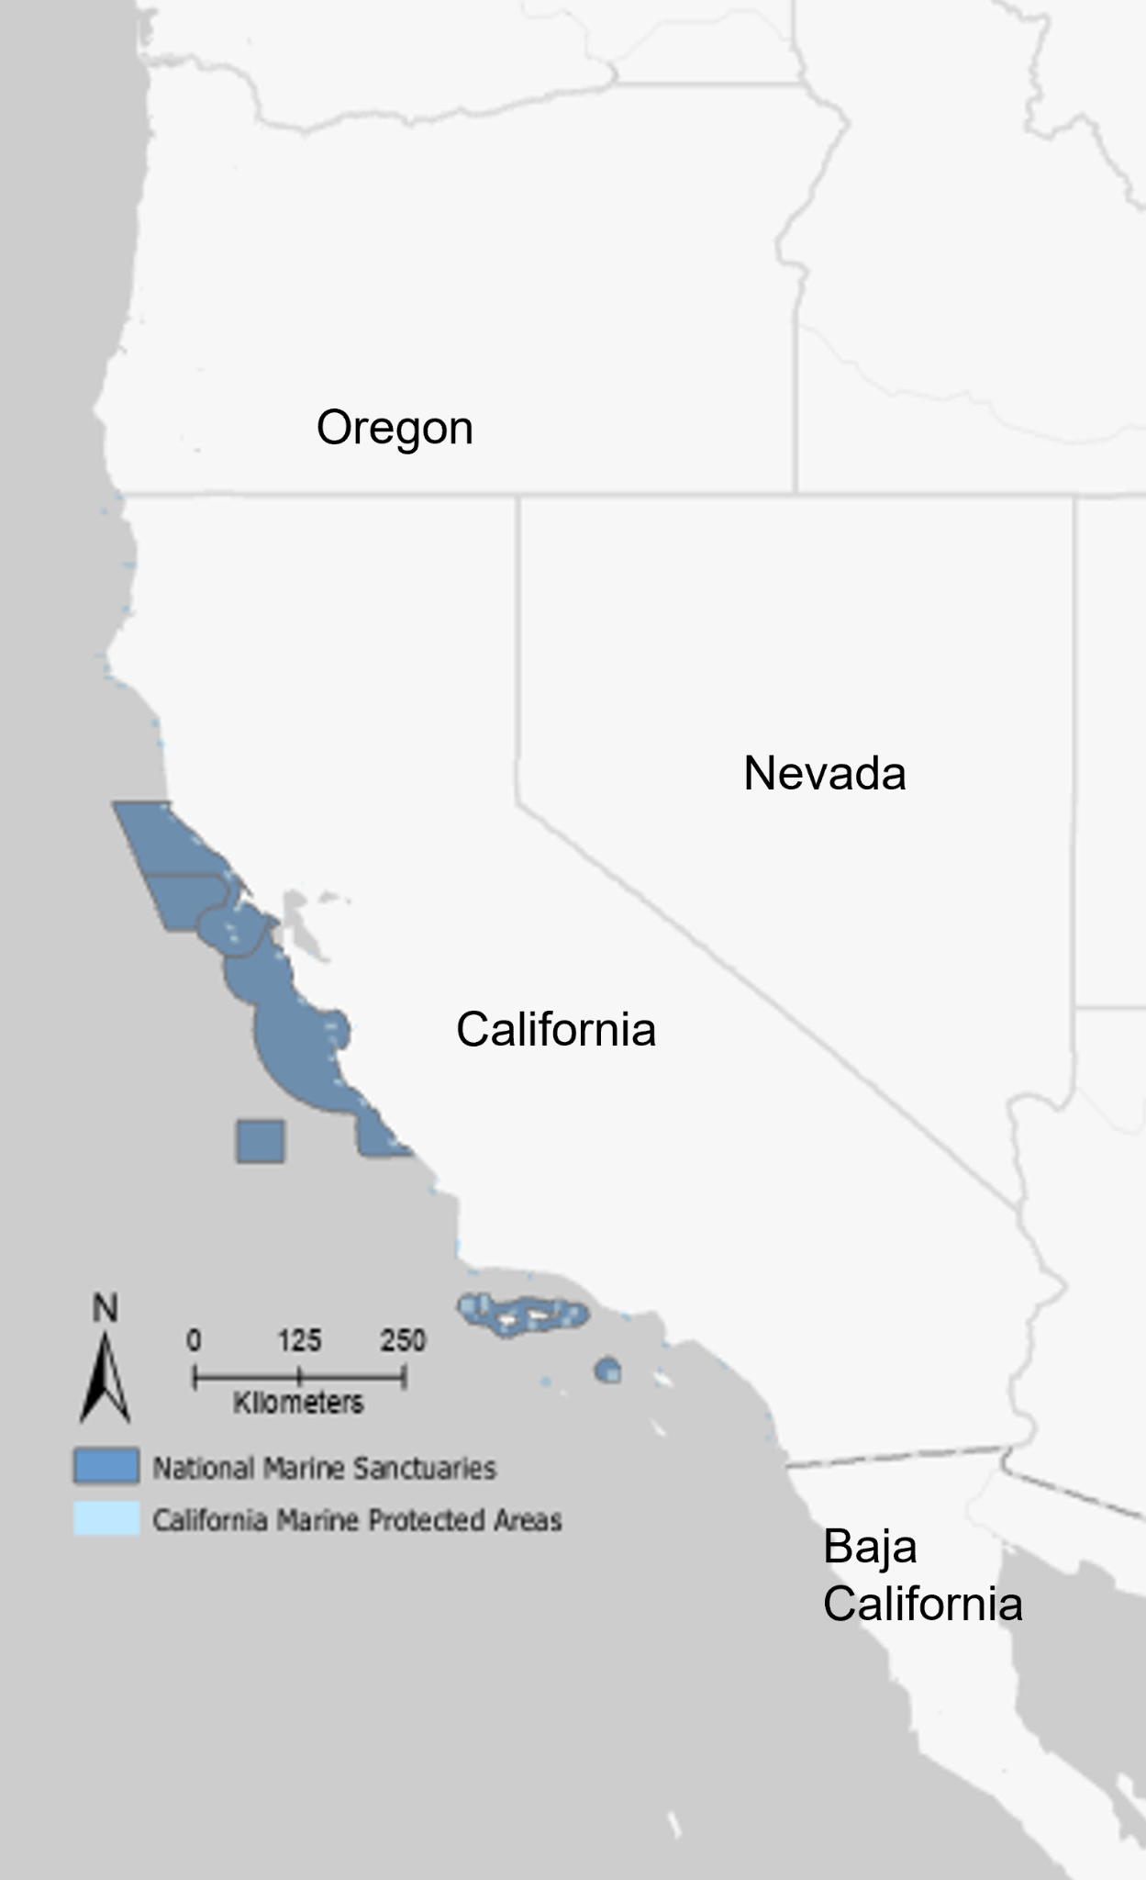

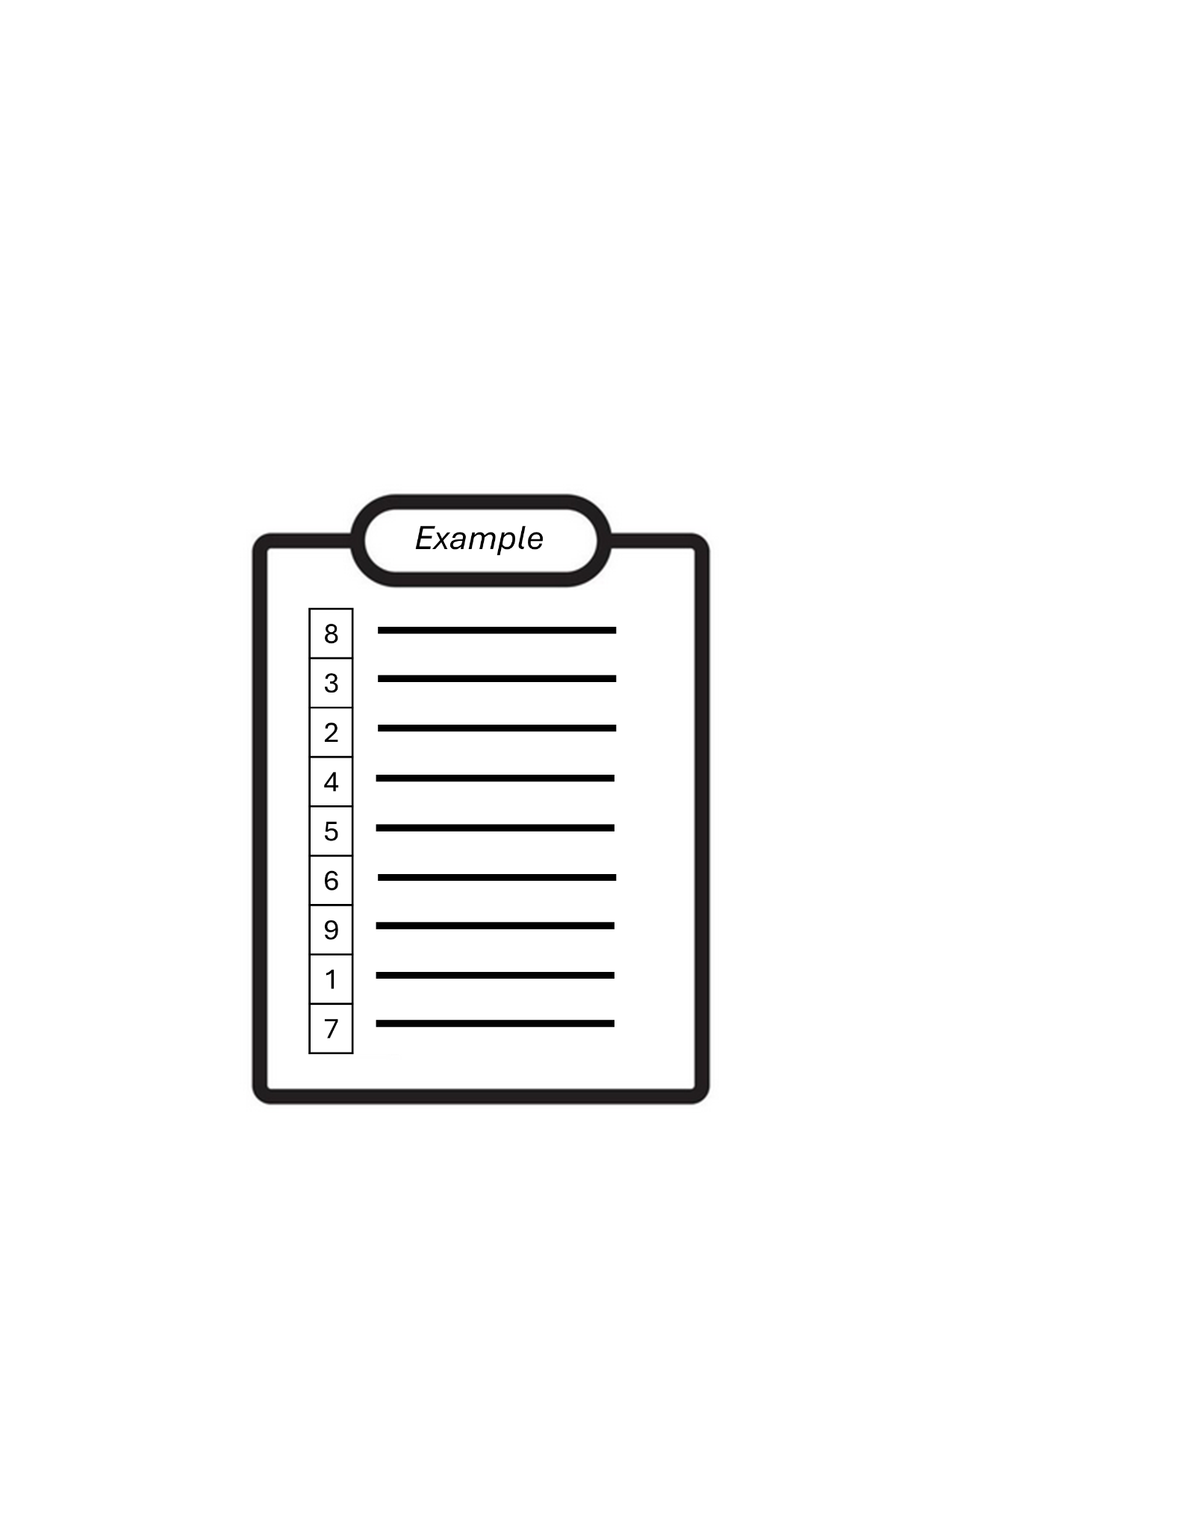

1. If a local ocean and/or coastal zone were to be managed for the benefit of your community, how important would the following characteristics be? Please order the items in the list below from 1 (most important) to 9 (least important)]?

|  |  |
| --- | --- |
| **Your Rank** | **Attribute** |
|  | Preventing large-scale industrial and/or commercial activity (i.e., oil drilling, commercial fishing, etc.) |
|  | Providing educational opportunities to improve ocean knowledge |
|  | Providing jobs and/or the opportunity to make money |
|  | Allowing locals to participate in rule-making and/or environmental monitoring |
|  | Increasing the availability of local seafood products |
|  | Enabling practices or activities that support local culture and/or traditions |
|  | Promoting connections between individuals and groups in my community |
|  | Providing protection for threatened plants or animals |
|  | Reducing risks of flooding, coastal erosion, and/or sea level rise |
|  | Providing or improving access to coastal areas |

***Next we will ask you questions about environmental change and the future of the ocean.***

1. Do you believe that climate change is happening?

* Yes, it is caused by human activities 🡪 CONTINUE to Q22b
* Yes, it is caused by natural forces 🡪 CONTINUE to Q22b
* Yes, it is caused by both human activities and natural forces 🡪 CONTINUE to Q22b
* Yes, but I don’t know what is causing it 🡪 CONTINUE to Q22b
* I’m not sure 🡪 SKIP to Q23
* No 🡪 SKIP to Q23

22b. [IF Q22 = YES] Please rank the degree to which you agree or disagree with the   
 following statements.

|  |  |  |  |  |  |  |
| --- | --- | --- | --- | --- | --- | --- |
|  | **Statement** | **Strong**  **Disagree** | **Disagree** | **Neutral** | **Agree** | **Strong Agree** |
| a | I am very knowledgeable about climate impacts to ocean and coastal areas in CA | 1 | 2 | 3 | 4 | 5 |
| b | Climate change will negatively impact the benefits that me, my family, and/or neighbors receive from ocean and coastal areas in CA | 1 | 2 | 3 | 4 | 5 |
| c | Marine Protected Areas can help me, my family, and/or neighbors adapt to climate impacts | 1 | 2 | 3 | 4 | 5 |

1. Please indicate the degree to which you agree or disagree with the following statements

|  |  |  |  |  |  |  |
| --- | --- | --- | --- | --- | --- | --- |
|  | **Statement** | **Strong**  **Disagree** | **Disagree** | **Neutral** | **Agree** | **Strong Agree** |
| a | Our children will benefit from ocean and coasts as much or more than me | 1 | 2 | 3 | 4 | 5 |
| b | Oceans and coasts can help my community adapt to future environmental and/or socioeconomic changes | 1 | 2 | 3 | 4 | 5 |
| c | I have confidence in the ability of the people in charge (i.e., state and federal government officials) to manage ocean and coastal resources for my communities’ benefit | 1 | 2 | 3 | 4 | 5 |
|  | I have a voice in the management of local ocean and coastal spaces. | 1 | 2 | 3 | 4 | 5 |

1. Is there anything else that you would like to share with us? ________________________________________________________________________________________________________________________________________________________________________________________________________________________________________________________________________________________________________________________________________________________________________________________________________________________________________________

***To conclude, we are going to ask you some demographic questions that are important for helping us understand your responses to the rest of the survey.***

1. What is the zip code of your primary residence (or, if you do not live in the US, your country of primary residence)? ____________

IF THAT ZIP CODE IS IN CALIFORNIA, how many years have you lived in California? __________ years

* I do not live in California

1. What is your race or ethnicity? (check ALL that apply)

* American Indian or Alaska Native
* Asian 🡪 CONTINUE to Q25b
* Black or African American
* Hispanic or Latino
* Middle Eastern or North African
* Native Hawaiian or Other Pacific Islander
* White

25b.. If you are Asian, how would you best characterize your Asian origins?

* East Asian
* South Asian
* Southeast Asian
* Other

1. Are you:

* Female
* Male
* Transgender, non-binary, or another gender
* Choose not to answer

1. What is your year of birth? __________________
2. What was your annual household income (i.e., the total income of all people that live in the same house or residence as you) before taxes in 2023?

* Less than $59,999
* $60,000 to $119,000
* $120,000 to $179,999
* $180,000 to $239,999
* $240,000 or more
* Prefer not to say

1. What is the highest level of education you have completed? (check one)

* Some high school or high school graduate (includes GED)
* Some college (less than or equal to 2 year associate’s degree)
* College graduate (bachelors degree)
* Graduate degree (professional, Masters, PhD, etc)
* Vocational degree
* Other (fill in the blank) __________________________
* Prefer not to say

1. How many people, including yourself, live in your household? __________
2. How many of these people are under 18 years old? __________
3. How would you characterize your swimming ability:

* I do not know how to swim
* Beginner
* Intermediate
* Advanced

**THANK YOU FOR YOUR RESPONSES!**

**If you would like more information about the project, you can visit our website or share your email address for project updates.** *(Your email will not be linked with your answers or shared outside of this project.)*

